Consent Form

Rating of Pictorial Images

IRB # 2009D1034

We are asking you to take part in a research study because you are a healthy individual aged 18 or older. In this study, you will be asked to make judgments about different pictures. The study consists of one session lasting approximately one hour. The study will be conducted by Dr. Reiko Graham (rg30@txstate.edu; 512-2445-6805) and Dr. Natalie Ceballos (nc18@txstate.edu; 512-245-8709).

In order to decide whether or not you wish to be part of this study, you need to know enough about its risks and benefits in order to make an informed judgment. This consent form gives you detailed information about the study, which a member of the research team will also discuss with you. By reading this form and talking to the researchers, you will learn about the different aspects of this research: its purpose, the procedures that will be performed, any risks of the procedures, and benefits of being in the study. Once you fully understand the study, you will be asked if you wish to participate. If so, you will be asked to sign this consent form.

Description of the Procedure: In this study, you will be asked to use a scantron form to make judgments about pictures that will appear on a projector screen in a small classroom setting. You may be asked about a variety of parameters, such as how familiar you are with the pictures or how exciting or appetizing they are to you. You may also be asked for basic background information (in writing) such as your age, years of education and whether or not you smoke cigarettes or consume alcohol on a regular basis

All participating individuals will sign a consent document and fill out a questionnaire requesting demographic information, however, participant data will be coded and kept separately from any document containing participant names or other identifiers. The activity will last no longer than one hour, and up to 100 pictures may be viewed in any given session.

Risks: There are no known risks associated with viewing objects or pictures other than what is required for prolonged concentration, which could result in fatigue. If you become uncomfortable at any time during your time in the lab, let the researchers know and the study will be stopped.

Also, if you find the pictures used in this study to be overly upsetting or distressing, please inform the researcher so that they can terminate the experiment. These pictures are of common items that you might see on a daily basis, so we do not expect that they will be too distressing. However, if for any reason you feel distressed or upset, the experiment will end. It is important to note that you may choose not to answer any question for any reason.

At the end of the consent document, we have included examples of the types of pictures you might see in this study.

If immediate care is needed, it is available at the Health Center at Texas State University (behind LBJ Student Center and Jackson Hall). Phone: day: 512-245-2161, after hours: 512-245-2167.

Psychological assistance may be obtained at the University Counseling Center. Location: 5-4.1 LBJ Student Center; Phone: 512-245-2208; E-mail: counselingcenter@txstate.edu.

Further information concerning your rights as a research participant can be obtained from the Texas State University Institutional Review Board at (512) 245-2314 or IRB@txstate.edu.

Benefits: One of the benefits of participating in this study is the sense of satisfaction that comes with contributing to scientific knowledge that will further our understanding how college students feel about pictures of common everyday items.

Compensation: You may be given bonus credit for Psychology courses, at the discretion of your instructor. If you choose not to participate, you may still be entitled to gain extra credit for these courses by participating in other experiments, attending talks or events on campus, or completing short written assignments (e.g., movie reviews, thought papers). Check with you instructor for clarification of your options.

Right to Withdraw: At any time, you may choose not to be in the study. If you withdraw from the study, no new data about you will be collected. You may also withdraw your authorization for us to use your data that have already been collected (other than the data needed to keep track of your withdrawal), but you must do this in writing.

Your decision not to participate, or to withdraw from the study, will not involve any penalty or loss of benefits to which you are entitled. If you decide to withdraw, we ask that you contact Dr. Reiko Graham or Dr. Natalie Ceballos in the Psychology Department at Texas State University, San Marcos, TX 78666. At that time, you will be asked for your permission to continue using the information about you that has already been collected prior to your withdrawal.

Early withdrawal will not penalize your relationship with the Department of Psychology or Texas State University.

Confidentiality: Study records that identify you will be kept confidential as required by law. Federal Privacy Regulations provide safeguards for privacy, security and authorized access to any information that you give. Except when required by law, you will not be identified by name, social security number, address, telephone number, or any other direct personal identifier on any study records disclosed outside of Texas State University. For records disclosed outside of Texas State University, you will be assigned a unique code number that will not identify you in any way. The key to this code will be kept in a locked file in the offices of Dr. Graham and Dr. Ceballos. Paper records of data will be retained for a period of 3 years, after which these items will be destroyed.

Questions concerning the study may be directed to Dr. Reiko Graham or Dr. Natalie Ceballos in the Department of Psychology, Texas State University, San Marcos, TX 78666; (512) 245-2526.

For questions regarding your rights as a research participant, contact the Texas State University Institutional Review Board at (512) 245-2314, Dr. Jon Lasser (512-245-3413; lasser@txstate.edu), and/or Ms. Becky Northcut , Compliance Specialist, 512-245-2102.

Statement of Consent: “The purpose of this study, the procedures to be followed, risks and benefits have been explained to me. I have been allowed to ask any questions on my mind, and my questions have been answered to my satisfaction. I have been told to contact Dr. Reiko Graham or Dr. Natalie Ceballos in the Department of Psychology at Texas State University if I have additional questions or concerns. I have read this consent form and agree to be in this study, with the understanding that I may withdraw at any time. I have been told that I will be given a signed copy of this consent form.”

________________________________________________________________________
Participant’s Name (PRINT)

________________________________ __________________
Participant’s Signature Date

___________________________________________
Signature of Person Obtaining Consent

Picture Examples:

In this study you might see pictures that fall within the following categories:

Pictures of Food: Pictures of People: Pictures of Beverages:



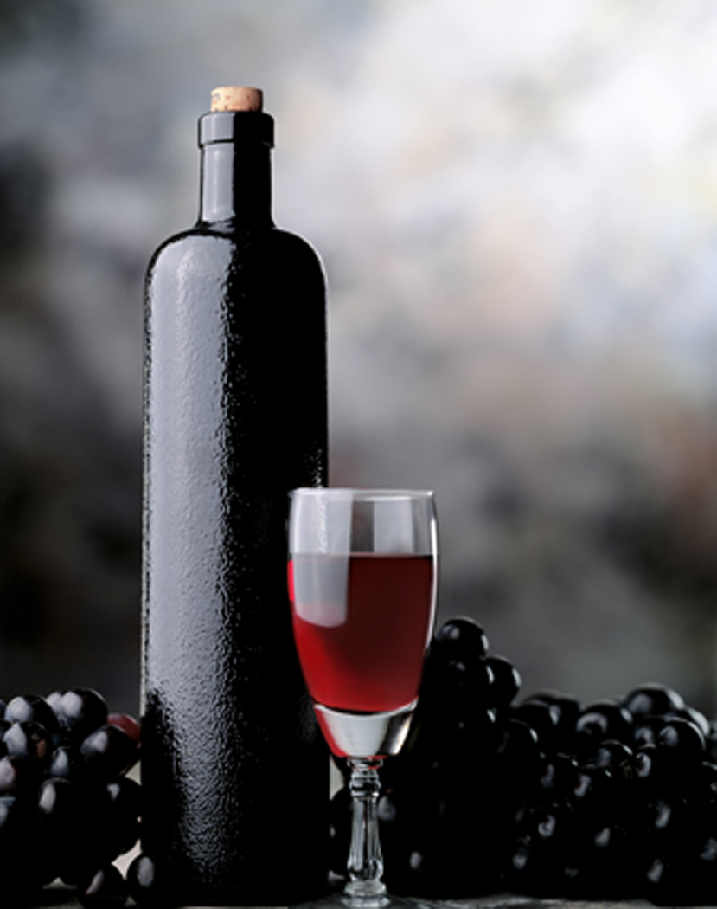


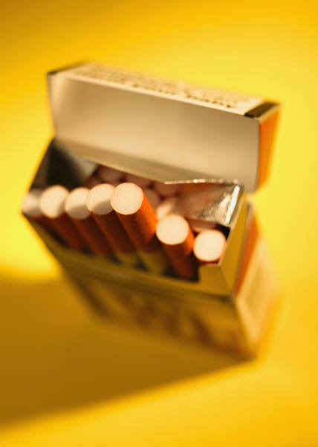

Pictures of Objects: Pictures of Shapes: Pictures of Activities:



Pictures of Complex Scenes:


